**Can Technical Indicator-based Stock Trading Strategies Perform Better than Top-performing Mutual Funds?**

Imran Al-Nahdy and Maaz Saad

Faculty of Business & IT, Ontario Tech University

MBAI 5300G - Programming and Data Processing

Dr. Amin Ibrahim

December 9, 2022

**Introduction**

Trading stocks has become a phenomenon that has only gained momentum in the last decade or so. Day trading is a concept where a person buys and sells stocks within a short time frame instead of holding the assets long term. People do this with the goal to make a small profit on each trade and hope the profits compound over time. Due to new tools like Robinhood and WealthSimple, investing in stocks has become extremely cheap and simple. But, without the proper knowledge of the stock market, it is highly likely that a novice investor will end up losing money instead of earning it. The stock market is extremely volatile and without the right expertise, it can be difficult to make informed decisions that are beneficial to an individual or an organization.

Now that we have a solid foundation upon which to base our paper, let’s take a deeper look at our objectives. In this research paper, we want to study whether technical indicator-based stock trading strategies perform better than top-performing mutual funds. The mutual fund that we have decided to use for the purposes of our study is TDB908. TDB908 is managed by TD Asset Management Inc out of Toronto, Canada. In order to streamline and simplify our study, our team decided to focus on the top 10 stocks held in TDB908. In the next section, we will learn more about the stocks that were picked. The time frame for our analysis is ten years, December 2012 - November 2022.

The technical indicator that we used to build our trading strategy is called Moving Average Convergence Divergence (MACD). We use this indicator to define a strategy that buys and/or sells a particular stock if certain conditions are met. And finally, we compute the compounded profit to see the potential gains or losses that would have occurred over the ten year period if we had traded in real life using said strategies. Now that we have a decent understanding of the goals of our study, we can dig deeper into the data.

**Data and Model**

All the data that was used in this analysis was extracted from Yahoo Finance through an API. The analysis was done in Python using a number of different libraries. Yahoo Finance has a community built library in Python called ‘yfinance’. This library was used to load the data for our ten stocks. [TDB908](https://ycharts.com/mutual_funds/M:TDB908.TO/holdings/overview) is a mutual fund comprising 25 stocks. We picked the top 10 stocks by their weightage in the mutual fund. The ten stocks that we selected from TDB908 are Apple, Microsoft, Amazon, Tesla, Google, Meta, Nvidia, Pepsi, Costco and Broadcom Inc. The default investment value for each stock was kept at $10,000.

From the Python library yfinance, the data that we loaded was on a daily basis for a period of ten years. The metrics that were available to us were the stock’s opening and closing prices, the highest and lowest price of the day, adjusted close and trade volume. For our research, the metric that we incorporated into our strategies was the closing price. Some of the other libraries that we used were pandas, numpy, plotly, matplotlib, datetime and for the purposes of backtesting, we used the backtesting library.

As mentioned in the introduction, the technical indicator that we used to develop our strategies is MACD. The MACD is an indicator that consists of the MACD line, the signal line and Histogram. The MACD line is the difference between a fast Exponential Moving Average (EMA) line and a slow EMA line. The signal line is the EMA line of the MACD. The histogram is the difference between the MACD and Signal Line. The user has the option to define the periods of the fast and slow moving averages. The most common values are 12 and 26 for fast and slow respectively and 9 for the period of the Signal Line. And we use these values for our default analysis.

Moving on, we will now explain the strategy that was designed to determine when to buy a stock and when to sell it. When the MACD line crosses above its signal line, a buy signal is generated by the system. On the other hand, when the MACD line crosses below the signal line, the system generates a signal to sell the stock held. 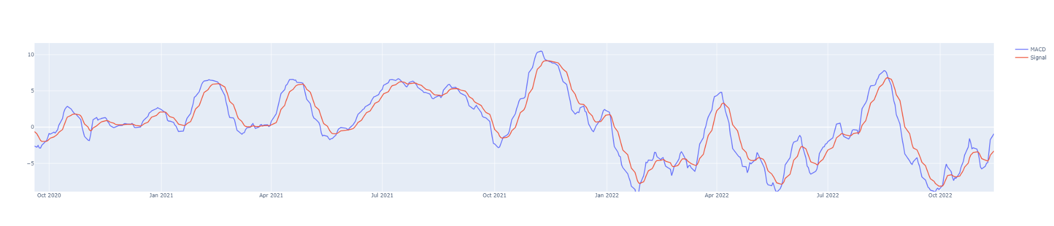

This is a visualization of Microsoft Stock since January 2022. This figure helps us visualize what it means for the MACD line (shown in blue) to cross over the signal line (shown in red) and vice versa.

The backtesting library was also used to define a function that allowed us to generate the returns, among a variety of other metrics for our list of stocks. The periods selected in the original run are the default periods defined earlier. The backtesting library is further utilized at the end to optimize position entrance and exit signal strategies. Additionally, we also implemented our strategy into the backtesting model after creating it in Python.

For the optimization model, we let the model select the periods for our fast, slow and signal lengths. The range we selected was between 5 and 100 in steps of 10, this was due to time constraints as computer power was limited and the recreation of our results was important. The model iterates over all possibilities and at the end shows the best possible combination of periods for each stock within our range. We also believe that obtaining the optimal MACD parameters for each individual stock is important as the default parameters do not work universally. Specific MACD parameters for individual stocks allowed for curated signals that allowed us to refine our results and maximize the total return on investment.

**Results and Analysis**

In this section, we will go over the results that are model generated. To start off, we will review the performance of the ten stocks with the default parameters of 12, 26, 9. Then, we will see the results after optimization and the optimized periods for each stock.

**Apple**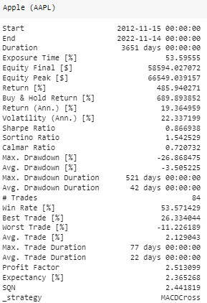

In the case of Apple, we can see that the time frame for our analysis is from 15th November 2012 till 14th November 2022. Our investment was $10,000 and our total return over the ten year period was 485.94%. This amounted to a total equity of $58,594.03 by the end of the ten year period. Additionally, the return per year was 19.36%. There were a total of 84 trades that were conducted by our model. The best trade earned us a return of 26.33% and the worst trade lost us 11.23%. The average trade percentage was 2.13% which means that for every trade, we earned 2.13% on average. Lastly, the average trade duration is 22 days which means that we held the stock for 22 days on average before selling it.

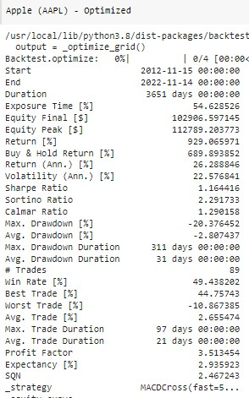

After optimization, we see that the total return has improved to 929.07%. The return per year has increased to 26.29%. The total number of trades conducted during the 10 year period have increased to 89 trades. The best trade now earns us a return of 44.76%. The worst trade now loses us 10.87%. The average trade percentage has increased to 2.66%. Furthermore, our model estimates these periods to be the best performing parameters: fast = 5, slow = 45, signal = 15.

**Microsoft**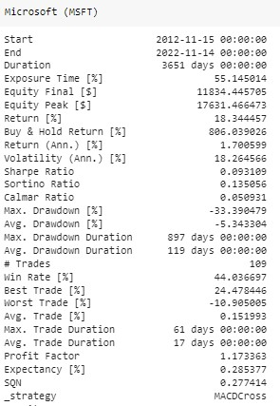

In the case of Microsoft, we can see that the time frame for our analysis is from 15th November 2012 till 14th November 2022. Our investment was $10,000 and our total return over the ten year period was 18.34%. This amounted to a total equity of $11,834.45 by the end of the ten year period. Additionally, the return per year was 1.70%. There were a total of 109 trades that were conducted by our model. The best trade earned us a return of 24.48% and the worst trade lost us 10.91%. The average trade percentage was 0.15% which means that for every trade, we earned 0.15% on average. Lastly, the average trade duration is 17 days which means that we held the stock for 17 days on average before selling it.

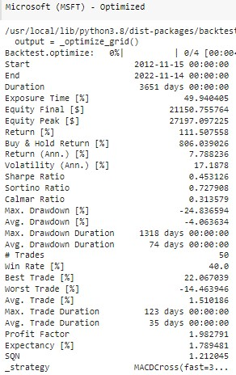

After optimization, we see that the total return has improved to 111.51%. The return per year has increased to 7.79%. The total number of trades conducted during the 10 year period have decreased to 50 trades. The best trade now earns us a return of 22.07%. The worst trade now loses us 14.46%. The average trade percentage has increased to 1.51%. Furthermore, our model estimates these periods to be the best performing parameters: fast = 35, slow = 75, signal = 15.

**Amazon**

In the case of Amazon, we can see that the time frame for our analysis is from 15th November 2012 till 14th November 2022. Our investment was $10,000 and our total return over the ten year period was 116.35%. This amounted to a total equity of $21,634.61 by the end of the ten year period. Additionally, the return per year was 8.03%. There were a total of 95 trades that were conducted by our model. The best trade earned us a return of 25.00% and the worst trade lost us 18.09%. The average trade percentage was 0.82% which means that for every trade, we earned 0.82% on average. Lastly, the average trade duration is 19 days which means that we held the stock for 19 days on average before selling it.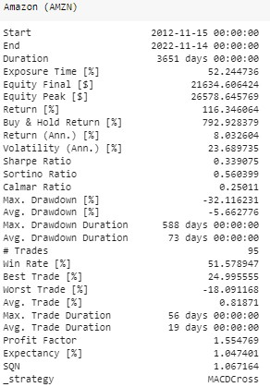

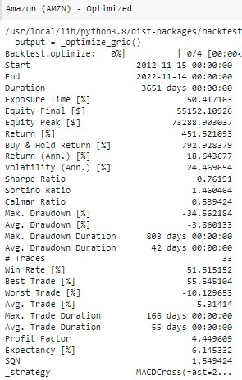

After optimization, we see that the total return has improved to 451.52%. The return per year has increased to 18.64%. The total number of trades conducted during the 10 year period have decreased to 33 trades. The best trade now earns us a return of 55.55%. The worst trade now loses us 10.13%. The average trade percentage has increased to 5.31%. Furthermore, our model estimates these periods to be the best performing parameters: fast = 25, slow = 65, signal = 35.

**Tesla**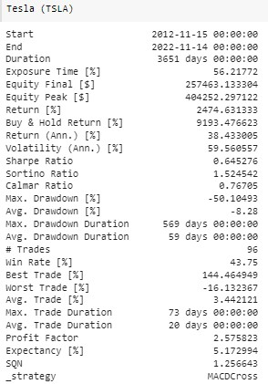

In the case of Tesla, we can see that the time frame for our analysis is from 15th November 2012 till 14th November 2022. Our investment was $10,000 and our total return over the ten year period was 2,474.63%. This amounted to a total equity of $257,463.13 by the end of the ten year period. Additionally, the return per year was 38.43%. There were a total of 96 trades that were conducted by our model. The best trade earned us a return of 144.46% and the worst trade lost us 16.13%. The average trade percentage was 3.44% which means that for every trade, we earned 3.44% on average. Lastly, the average trade duration is 20 days which means that we held the stock for 20 days on average before selling it. 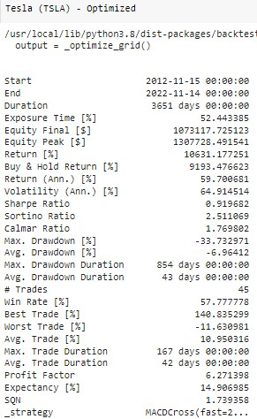

After optimization, we see that the total return has improved to 10,631.18%. The return per year has increased to 59.70%. The total number of trades conducted during the 10 year period have decreased to 45 trades. The best trade now earns us a return of 140.84%. The worst trade now loses us 11.63%. The average trade percentage has increased to 10.95%. Furthermore, our model estimates these periods to be the best performing parameters: fast = 25, slow = 75, signal = 15.

**Google**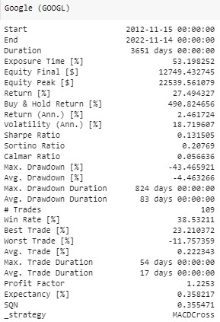

In the case of Google, we can see that the time frame for our analysis is from 15th November 2012 till 14th November 2022. Our investment was $10,000 and our total return over the ten year period was 27.49%. This amounted to a total equity of $12,749.43 by the end of the ten year period. Additionally, the return per year was 2.46%. There were a total of 109 trades that were conducted by our model. The best trade earned us a return of 23.21% and the worst trade lost us 11.76%. The average trade percentage was 0.22% which means that for every trade, we earned 0.22% on average. Lastly, the average trade duration is 17 days which means that we held the stock for 17 days on average before selling it. 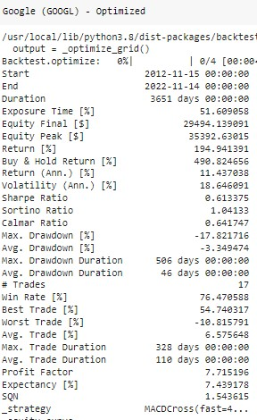

After optimization, we see that the total return has improved to 194.94%. The return per year has increased to 11.44%. The total number of trades conducted during the 10 year period have decreased to 17 trades. The best trade now earns us a return of 54.74%. The worst trade now loses us 10.82%. The average trade percentage has increased to 6.58%. Furthermore, our model estimates these periods to be the best performing parameters: fast = 45, slow = 85, signal = 85.

**Meta**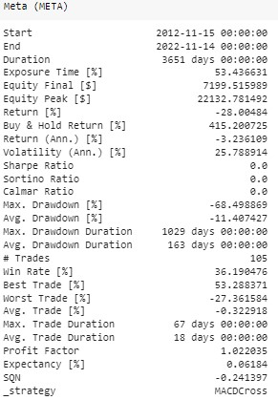

In the case of Meta, we can see that the time frame for our analysis is from 15th November 2012 till 14th November 2022. Our investment was $10,000 and our total return over the ten year period was -28.04%. This amounted to a total equity of $7,199.52 by the end of the ten year period. Additionally, the return per year was -3.24%. There were a total of 105 trades that were conducted by our model. The best trade earned us a return of 53.29% and the worst trade lost us 27.36%. The average trade percentage was -0.32% which means that for every trade, we lost -0.32% on average. Lastly, the average trade duration is 18 days which means that we held the stock for 18 days on average before selling it.

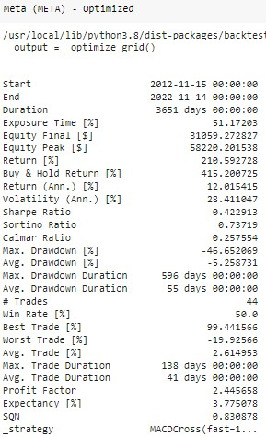

After optimization, we see that the total return has improved to 210.59%. The return per year has increased to 12.02%. The total number of trades conducted during the 10 year period have decreased to 44 trades. The best trade now earns us a return of 99.44%. The worst trade now loses us 19.93%. The average trade percentage has increased to 2.61%. Furthermore, our model estimates these periods to be the best performing parameters: fast = 15, slow = 35, signal = 95.

**Nvidia**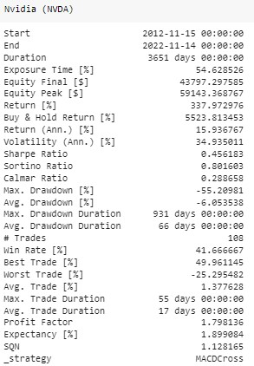

In the case of Nvidia, we can see that the time frame for our analysis is from 15th November 2012 till 14th November 2022. Our investment was $10,000 and our total return over the ten year period was 337.97%. This amounted to a total equity of $43,797.30 by the end of the ten year period. Additionally, the return per year was 15.94%. There were a total of 108 trades that were conducted by our model. The best trade earned us a return of 49.96% and the worst trade lost us 25.30%. The average trade percentage was 1.38% which means that for every trade, we earned 1.38% on average. Lastly, the average trade duration is 17 days which means that we held the stock for 17 days on average before selling it.

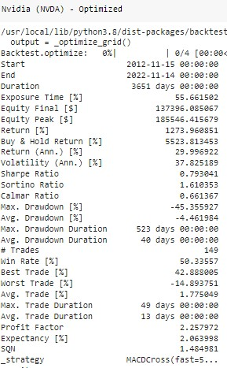

After optimization, we see that the total return has improved to 1,273.96%. The return per year has increased to 30.00%. The total number of trades conducted during the 10 year period have increased to 149 trades. The best trade now earns us a return of 42.89%. The worst trade now loses us 14.90%. The average trade percentage has increased to 1.78%. Furthermore, our model estimates these periods to be the best performing parameters: fast = 5, slow = 55, signal = 5.

**PepsiCo**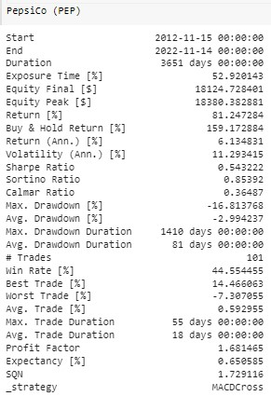

In the case of PepsiCo, we can see that the time frame for our analysis is from 15th November 2012 till 14th November 2022. Our investment was $10,000 and our total return over the ten year period was 81.25%. This amounted to a total equity of $18,124.73 by the end of the ten year period. Additionally, the return per year was 6.13%. There were a total of 101 trades that were conducted by our model. The best trade earned us a return of 14.47% and the worst trade lost us 7.31%. The average trade percentage was 0.59% which means that for every trade, we earned 0.59% on average. Lastly, the average trade duration is 18 days which means that we held the stock for 18 days on average before selling it.

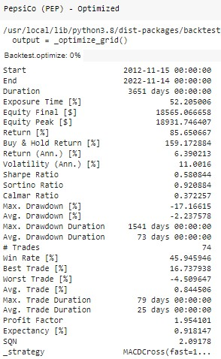

After optimization, we see that the total return has improved to 85.65%. The return per year has increased to 6.39%. The total number of trades conducted during the 10 year period have decreased to 74 trades. The best trade now earns us a return of 16.74%. The worst trade now loses us 4.51%. The average trade percentage has increased to 0.85%. Furthermore, our model estimates these periods to be the best performing parameters: fast = 15, slow = 25, signal = 15.

**Costco**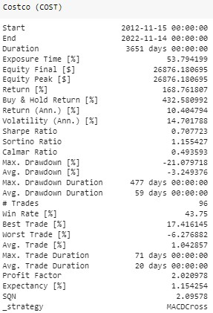

In the case of Costco, we can see that the time frame for our analysis is from 15th November 2012 till 14th November 2022. Our investment was $10,000 and our total return over the ten year period was 168.76%. This amounted to a total equity of $26,876.18 by the end of the ten year period. Additionally, the return per year was 10.40%. There were a total of 96 trades that were conducted by our model. The best trade earned us a return of 17.42% and the worst trade lost us 6.28%. The average trade percentage was 1.04% which means that for every trade, we earned 1.04% on average. Lastly, the average trade duration is 20 days which means that we held the stock for 20 days on average before selling it.

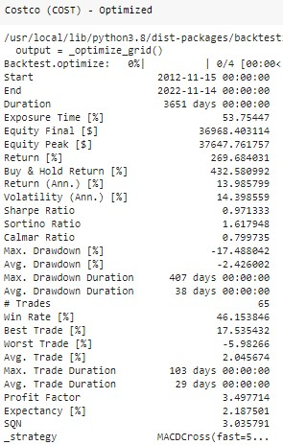

After optimization, we see that the total return has improved to 269.68%. The return per year has increased to 13.99%. The total number of trades conducted during the 10 year period have decreased to 65 trades. The best trade now earns us a return of 17.54%. The worst trade now loses us 5.98%. The average trade percentage has increased to 2.05%. Furthermore, our model estimates these periods to be the best performing parameters: fast = 5, slow = 25, signal = 75.

**Broadcom Inc**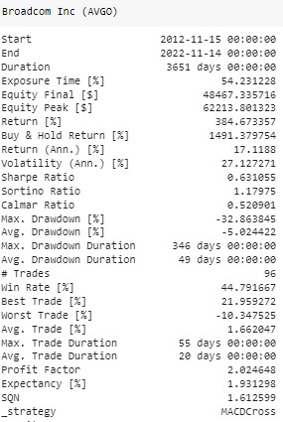

In the case of Broadcom Inc, we can see that the time frame for our analysis is from 15th November 2012 till 14th November 2022. Our investment was $10,000 and our total return over the ten year period was 384.67%. This amounted to a total equity of $48,467.34 by the end of the ten year period. Additionally, the return per year was 17.12%. There were a total of 96 trades that were conducted by our model. The best trade earned us a return of 21.96% and the worst trade lost us 10.35%. The average trade percentage was 1.66% which means that for every trade, we earned 1.66% on average. Lastly, the average trade duration is 20 days which means that we held the stock for 20 days on average before selling it.

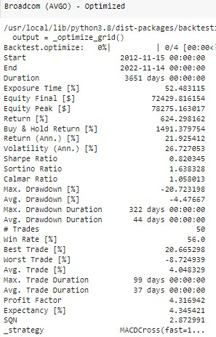

After optimization, we see that the total return has improved to 624.30%. The return per year has increased to 21.93%. The total number of trades conducted during the 10 year period have decreased to 50 trades. The best trade now earns us a return of 20.67%. The worst trade now loses us 8.72%. The average trade percentage has increased to 4.05%. Furthermore, our model estimates these periods to be the best performing parameters: fast = 15, slow = 25, signal = 55.

**Conclusion**

In this research paper, we created strategies to buy and sell stock using MACD. We ran two versions of our model. In the first model, we used default periods for MACD. And in the second version, we ran the same model but optimized the periods. And we learned that by optimizing the parameters of MACD, we can improve our returns.

If we look at the average return for our ten stocks across the 10 year period, we get an overall average return of 406.74%. And once we optimize the MACD parameters, we get an overall average return of 1,459.67%. Moreover, the average return per year for the 10 stocks is 11.63%. And after optimization, the average return per year comes out to 20.82%.

According to [Market & Research](https://marketsandresearch.td.com/tdwca/Public/MutualFundsProfile/PerformanceAndRisk/ca/TDB908), the 10 year return for TDB908 was 15.92%. By using our optimized strategy, we were able to beat those returns by achieving 20.82%. In order to improve our strategies, we would need to run more variations of this model with more stocks and a larger data set. Additionally, we can create new strategies by incorporating other metrics such as RSI and Bollinger Bands. We learned a great deal about trading strategies and programming in this project and also this course as a whole.

**References**

TDB908 Performance & Returns | TD NASDAQ Index - e. https://ycharts.com/mutual_funds/M:TDB908.TO/performance. Accessed 9 Dec. 2022.

Pat Tong Chio. (2022). A comparative study of the MACD-base trading strategies: evidence from the US stock market. arXiv.org.

Bhandari, B. (2011). Trading stocks with MACD. Futures (Cedar Falls, Iowa), 40(12), 32–.

Mutual Funds Profile Performance & Risk. https://marketsandresearch.td.com/tdwca/Public/MutualFundsProfile/PerformanceAndRisk/ca/TDB908. Accessed 9 Dec. 2022.

Backtesting: Backtest Trading Strategies in Python. OS Independent. PyPI, https://kernc.github.io/backtesting.py/. Accessed 9 Dec. 2022.